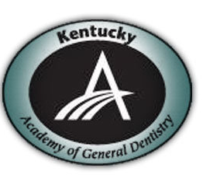
The Kentucky AGD presents...

Dental Lasers Improving Clinical Outcomes and Growing Practice Revenues
Hands-ON Laser CE course
Friday February 19, 2016; 8:45 am-4 pm EST.
The course will award 6 hours of hands-on CE credit.
It will be held at ADL Dental Laboratory 4411 Poplar Level Rd, Louisville, KY

Cost is $199 each for AGD Members and their Hygienists
and $299 each for Non-members and their Hygienists.
Please RSVP to Maegan Bennett at maegan03@hotmail.com or 270-401-3928

Dental Lasers Improving Clinical Outcomes and Growing Practice Revenues
Presented by Dr. Bruce Cassis

Utilizing a dental laser can help to offer an unparalleled clinical experience for both dental professionals and their patients. If you could imagine being able to offer a more efficient dental appointment, greater comfort to your patient, and the opportunities to expand the dental services available in your practice. Learn how implementing the use of a dental laser in your practice can:
•address everyday challenges •open revenue streams not yet explored by most practices •help you win the PPO game.

During the hands-on session, this presentation will follow a TELL, SHOW format.

General course objectives:
- Review the history of dental lasers
- Review the physics of dental lasers
- Describe laser energy production and its uses in dentistry
- Define the acronym for LASER
- Describe the hydrophotonics phenomenon
- Name at least 4 dental procedures enhanced or improved by the use of a laser
- Demonstrate how to incorporate a dental laser into your dental practice

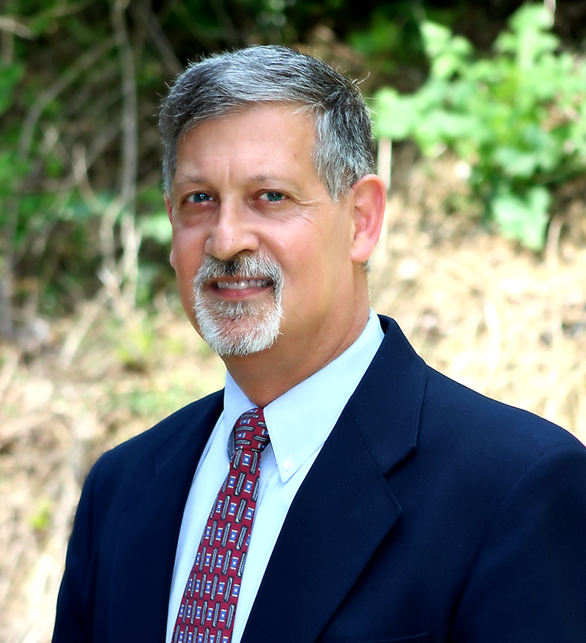
Dr. Bruce Cassis is a 1980 graduate of West Virginia University School of Dentistry, he maintains a successful dental practice in Fayetteville, West Virginia, and is a clinical instructor for certification level training utilizing the Waterlase MD Er, Cr: YSGG laser and diode wavelength systems. He has successfully trained thousands of dentists in successfully implementing laser assisted dentistry into their practices. Dr. Cassis has earned his Mastership Certification from both the World Clinical Laser Institute and the Academy of General Dentistry. He has served as Chair on the Program Approval for Continuing Education (PACE) Council for the Academy of General Dentistry, and is currently the chairperson for the AGD Communications Council.

Dr. Cassis contributed to research conducted by Shareef Madavi, of SM2 Consulting, and the publication, “Case Studies on Waterlase in Today’s Dental Practice, Investing in Your Patients an
d Your Practice”. The article was a stand-alone publication and was also featured in Dental Economics. Dr. Cassis also helped in the development and clinical testing of the WaterlaseMD turbo laser hand piece system.

Dr. Cassis is a member of the Academy of General Dentistry, American Academy of Cosmetic Dentistry, American Dental Association, Dental Organization for Conscious Sedation, West Virginia Dental Association, and The West Virginia Academy of General Dentistry. He is also active in his church and community. He is a life-long member of the St. George Orthodox Cathedral and is a member of the choir. He is active in the Fayetteville Lions Club having served as a past-president in the club.

To register contact Maegan Bennett at (270) 401-3928 or complete the form below and mail to 950 N. Mulberry St. ste 170 Elizabethtown KY 42701 (please note: SPACE IS LIMITED)

Name________________________________________DMD DDS MD PHD OTHER AGD ID # _____________ Date ________
Mailing Address ____________________________________________________

City, State ________________________________________ Zip_________

E-Mail _______________________________________Telephone____________
PAYMENT METHOD (Payment is due at time of registration. Payment may be made by check, MasterCard or Visa).

Credit Card Number______________________ Exp. Date______ Security Code _____

Credit Card Holder Name ____________________________________________

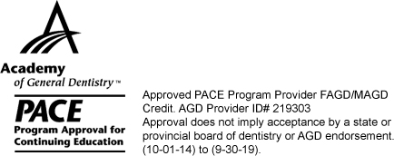
Total Amount Enclosed $ ______________ Check Number _________ (make check payable to the KyAGD)
Cancellation Policy: Full refunds will be given for cancellations received in writing before February 5th; cancellations after that time will not be refunded. Refunds are limited to registration fees only; not including airline, hotel or other associated fees.

