The Future of Private Practice: How will the Affordable Care Act, the rapid rise of Corporate Dentistry, and the Dental Insurance Business impact the private practice of dentistry

$99 each for Member dentists and their staff
$199 each for Non-Member dentists and their staff
Saturday, March 26th, 2016 9:00 AM–12:00 PM
The course will award 3 hours of CE credit and will be held at
ADL Laboratory 4411 Poplar Level Rd, Louisville, KY 40213
To RSVP call or email Maegan Bennett 270-401-3928 or maegan03@hotmail.com

Course Overview
This is a critical time in dentistry and not a time for complacency. Understanding the key forces at work will assist the profession in defining its own destiny. Ignoring what is happening in the health and consumer environments will mean ceding the future of your profession to others. The solo practice of dentistry is still the most prevalent but this is changing rapidly. Most of the dentists graduating today are not going into private practice directly our of school and many indicate they do not intend to be in a solo private practice. What is driving the young dentists career choices and how with that affect the practice of dentistry?

Course Objectives
At the conclusion of this presentation each participant should be able to:
1. Identify the different types of “corporate dentistry”
2. Understand why there is increased demand for value in dental care spending
3. Understand why the emphasis on cost-effectiveness and outcomes will
encourage alternative models of dental care
4. Plan a strategy to increase the value of your practice both as a profit center
and for future sale.

Speaker
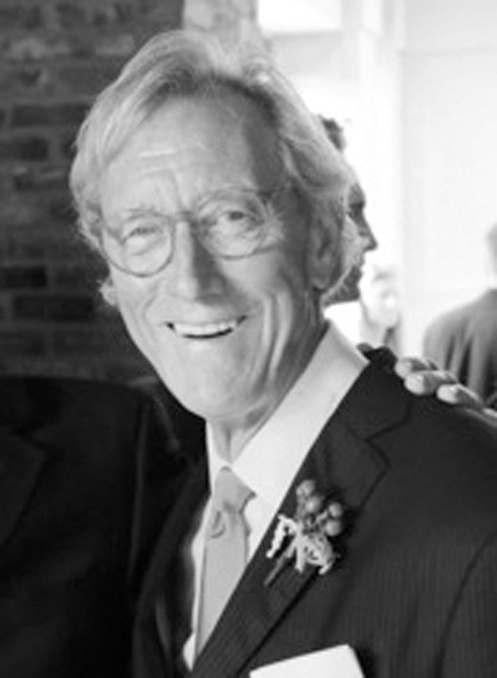
Dr. Coffman earned his DMD from the University of Kentucky College of Dentistry in 1978. He was in both group and solo practices for 32 years before retiring in July 2010. Dr. Coffman is an accredited member of the American Academy of Cosmetic Dentistry. He is an Assistant Professor at the University of Kentucky College of Dentistry, where he is the Director of the Practice Management Course for fourth-year dental students and Director of Continuing Education. His passion now is to help other dentists become successful both financially and clinically using a health-centered approach and eliminating insurance dependency.

To register contact Maegan Bennett at (270) 401-3928 or complete the form below and mail to
950 N. Mulberry St. ste 170 Elizabethtown KY 42701 (please note: SPACE IS LIMITED)

Name______________________________________DMD DDS MD PHD OTHER
AGD ID # _____________ Date ________
Mailing Address ____________________________________________________
City, State ________________________________________ Zip_________
E-Mail _______________________________________Telephone____________
PAYMENT METHOD (Payment is due at time of registration. Payment may be made by check, MasterCard or Visa).
Credit Card Number__________________ Exp. Date______ Security Code _____
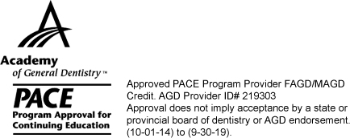
Credit Card Holder Name _____________________________________

Total Amount Enclosed $ ______________ Check Number _________
(make check payable to the KyAGD)

